SEC Form 3
FORM 3 | UNITED STATES SECURITIES AND EXCHANGE COMMISSION
 | Washington, D.C. 20549
 | Washington, D.C. 20549 |  | OMB APPROVAL
 | INITIAL STATEMENT OF BENEFICIAL OWNERSHIP OF SECURITIES
 | INITIAL STATEMENT OF BENEFICIAL OWNERSHIP OF SECURITIES |  | OMB Number: | 3235-0104
 |  |  | Estimated average burden
 | Filed pursuant to Section 16(a) of the Securities Exchange Act of 1934 |  | hours per response: | 0.5
or Section 30(h) of the Investment Company Act of 1940
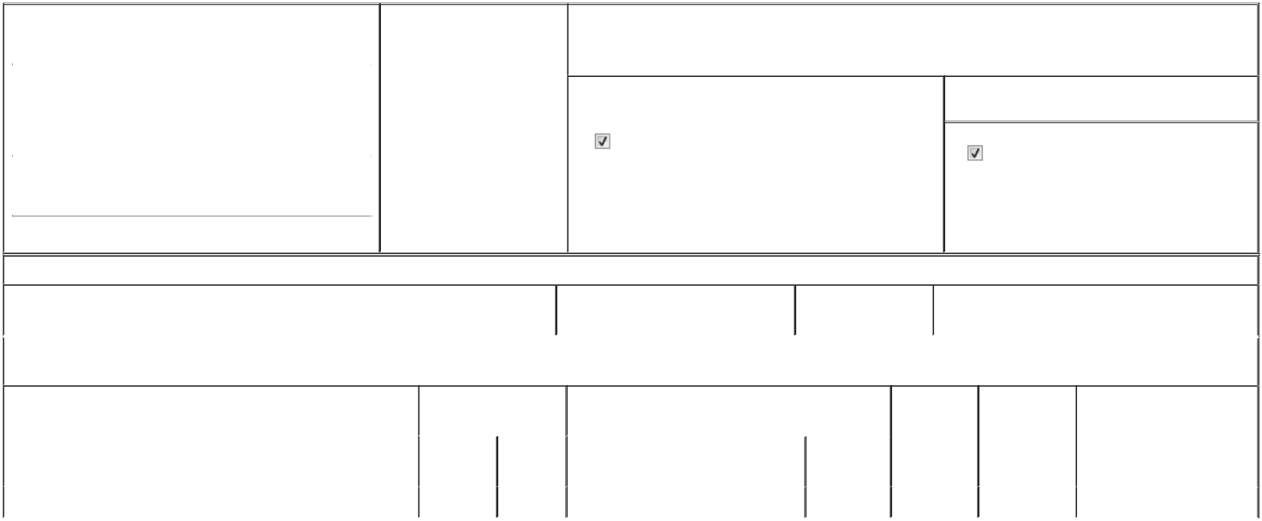

1. Name and Address of Reporting Person* |  |  |  | 2. Date of Event Requiring
 |  | MUELLER PAUL MICHAEL |  | Statement (Month/Day/Year)
 |  | MUELLER PAUL MICHAEL |  | 03/18/2026

3. Issuer Name and Ticker or Trading Symbol

MEXICAN ECONOMIC DEVELOPMENT INC [ FMX ]

 | (Last) | (First) | (Middle)
 | AVENIDA GENERAL ANAYA 60|
 | BELLA VISTA
(Street)
 | MONTERREY | O5 | 64410

- Relationship of Reporting Person(s) to Issuer (Check all applicable)
Director | 10% Owner
Officer (give title | Other (specify below)
below) | Other (specify below)

CEO VALORA

- If Amendment, Date of Original Filed (Month/Day/Year)

- Individual or Joint/Group Filing (Check Applicable Line)

Form filed by One Reporting Person

Form filed by More than One Reporting Person

(City) (State) (Zip)

Table I - Non-Derivative Securities Beneficially Owned

 | 1. Title of Security (Instr. 4) | 2. Amount of Securities Beneficially | 3. Ownership Form: | 4. Nature of Indirect Beneficial Ownership (Instr. 5)
 |  | Owned (Instr. 4) | Direct (D) or Indirect
 |  |  | (I) (Instr. 5)

Table II - Derivative Securities Beneficially Owned

(e.g., puts, calls, warrants, options, convertible securities)

 | 1. Title of Derivative Security (Instr. 4) | 2. Date Exercisable and |  | 3. Title and Amount of Securities Underlying Derivative |  | 4. | 5. Ownership | 6. Nature of Indirect Beneficial
 |  | Expiration Date |  | Security (Instr. 4) |  | Conversion | Form: Direct | Ownership (Instr. 5)
 |  | (Month/Day/Year) |  |  |  | or Exercise | (D) or Indirect
 |  |  |  |  |  | Price of | (I) (Instr. 5)
 |  |  |  |  | Amount or | Price of | (I) (Instr. 5)
 |  |  |  |  | Amount or | Derivative
 |  | Date | Expiration | Title | Number of | Security
 |  | Exercisable | Date | Title | Shares
 | Phantom Stock | 03/31/2026 | 03/31/2026 | BD Units | 237,801.4⁽¹⁾ | (2) | D
 | Explanation of Responses:

- These securities reported herein are held in the form of Restricted Stock Units ("RSUs"). Each RSU represents 10 BD Units. Each BD Unit consists of one Series B Share, two Series D-B Shares and two Series D-L Shares ("BD Unit"), without par value ("Series D-B Shares" and "Series D-L Shares", respectively).

- Each share of phantom stock represents an economic interest equivalent of 10 BD Units of the Issuer and is settled exclusively in cash on March 31 of the applicable payment year.

Remarks:

Exhibit 24 - Power of Attorney

 | Sergio Rodriguez Perez, Attorney in |  |  | 03/31/2026
 | Fact
 | ** Signature of Reporting Person |  |  | Date
Reminder: Report on a separate line for each class of securities beneficially owned directly or indirectly.
* If the form is filed by more than one reporting person, see Instruction 5 (b)(v).
** Intentional misstatements or omissions of facts constitute Federal Criminal Violations See 18 U.S.C. 1001 and 15 U.S.C. 78ff(a).
Note: File three copies of this Form, one of which must be manually signed. If space is insufficient, see Instruction 6 for procedure.
Persons who respond to the collection of information contained in this form are not required to respond unless the form displays a currently valid OMB Number.



